DATA ANALYSIS

TOPIC : Fifa Data Set (Greate Learning)

Q1. Importing libraries

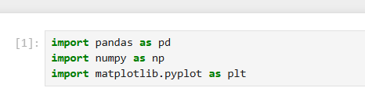

Q2. Uploading csv file

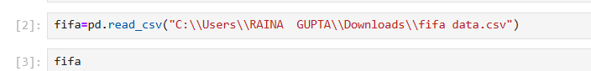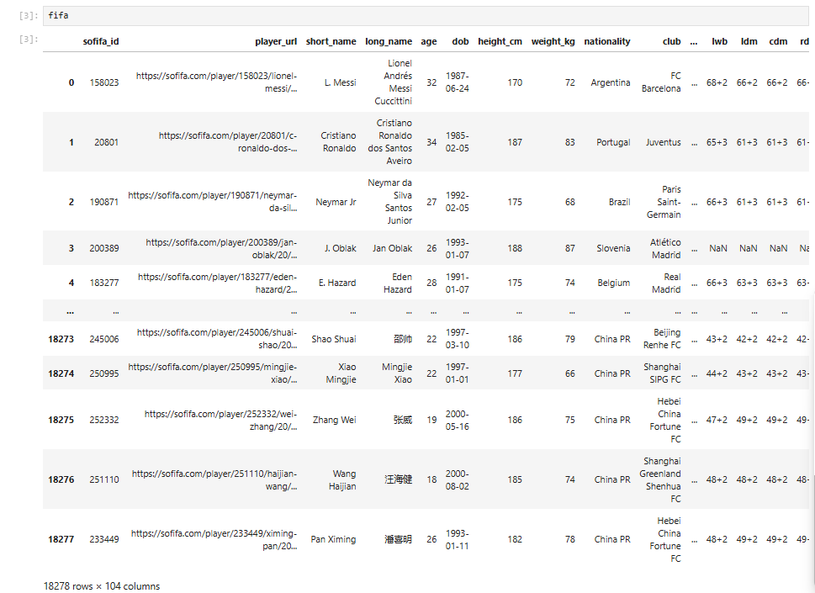

Q3. Display first few rows

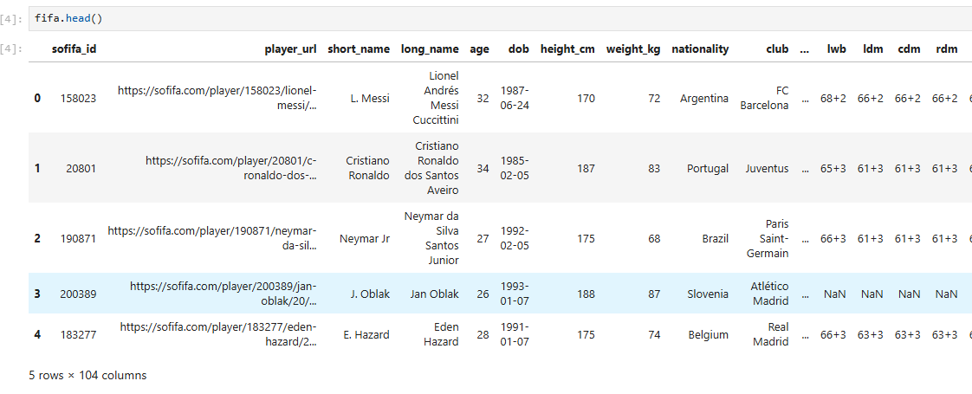

Q4. Display last few rows

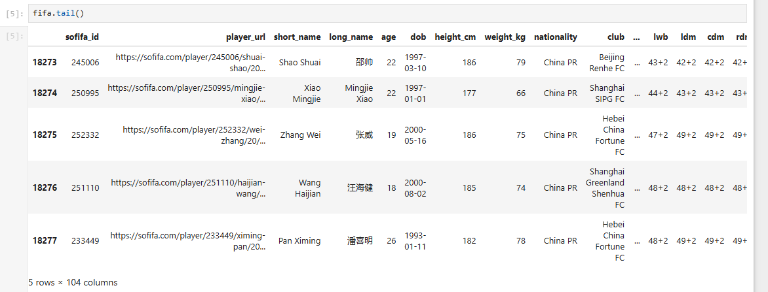Q5. Check dataset shape

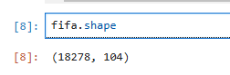

Q6. Check column names

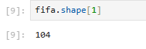

Q7. Check rows names

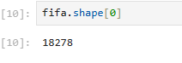

Q8. Finding the columns data types

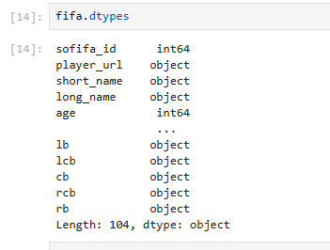

Q9. Table Columns

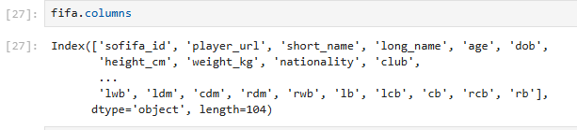

Q10. Summary statistics

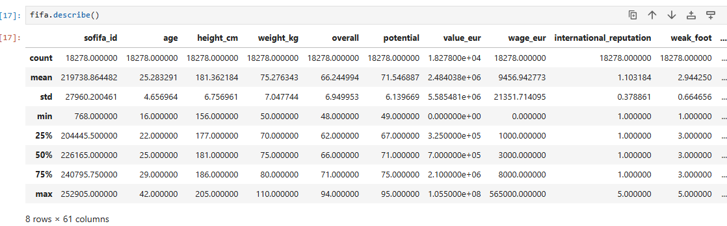

Q11. check if there are any missing values in data frame

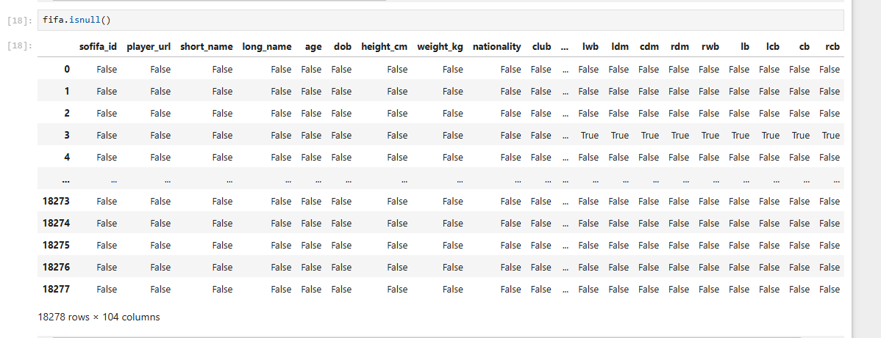

Q12. How many missing values are in each column

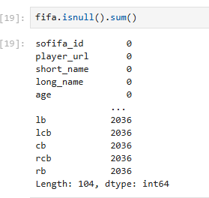

Q13. Get the age of players at index 0 and 4.

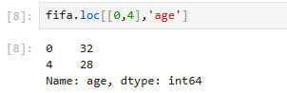

Q14. How can I get the unique nationalities

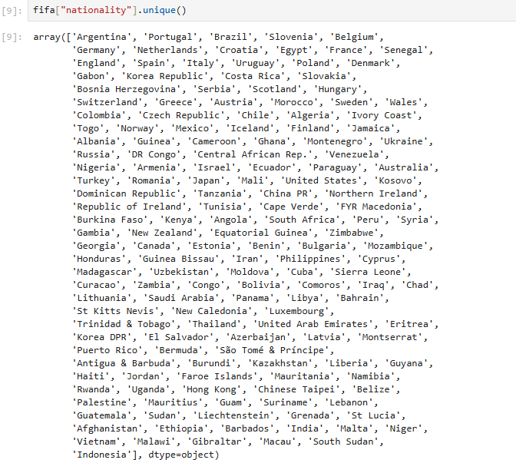

Q15. How many unique nationalities are in the FIFA dataset

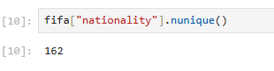

Q16. How many unique clubs

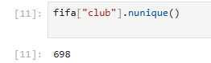

Q17. Retrieve all players from the FIFA dataset whose nationality is India

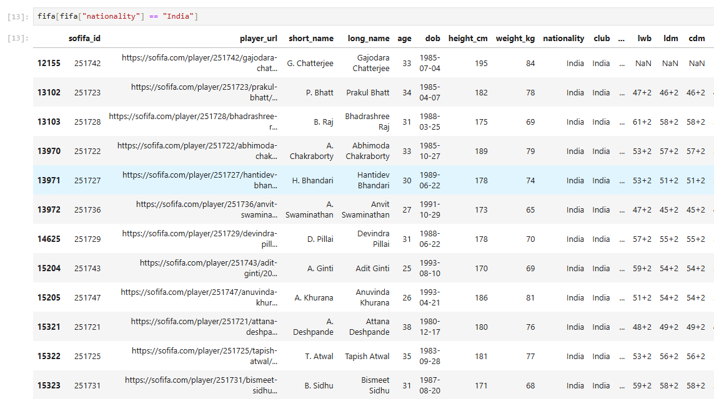

Q18. Get all players from the FIFA dataset who are older than 40

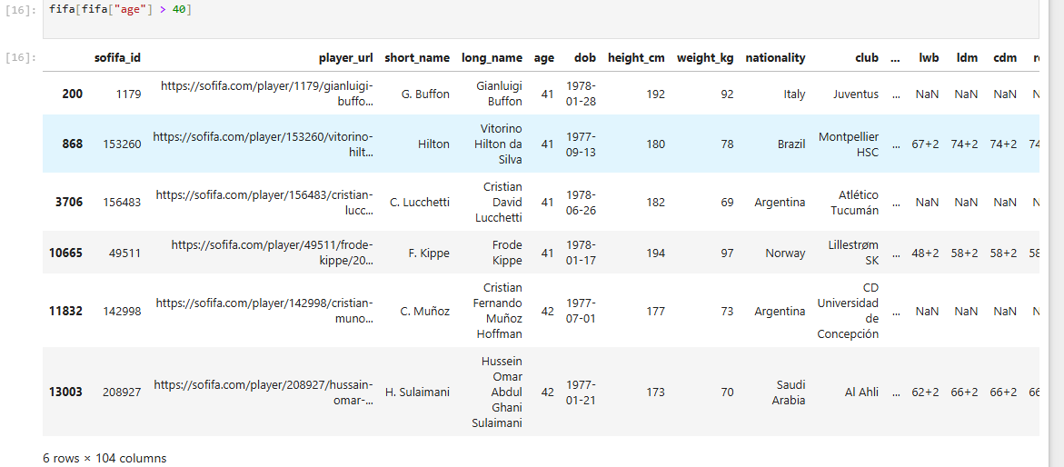

Q19. Get all players from the FIFA dataset who are under 40 years old and have a potential rating above 93.

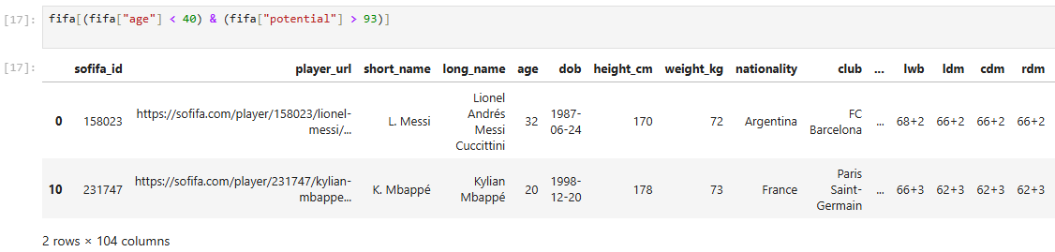

Q20. Retrieve all goalkeepers (GK) data

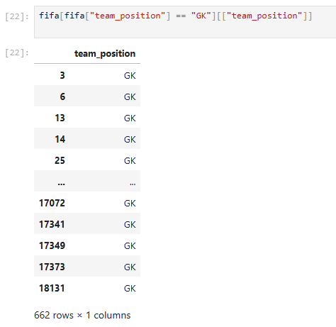

Q21. Get all players from dataset who play as CB, LB, or RB

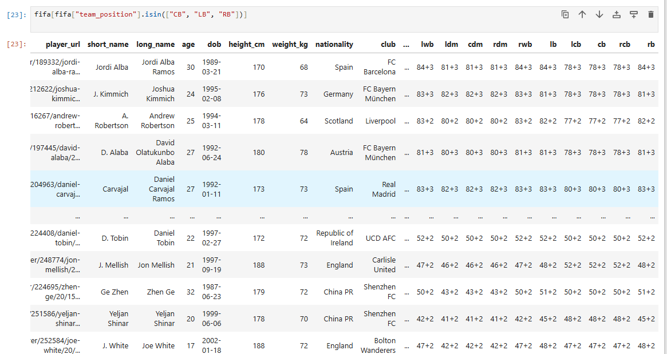

Q22. Get the names and overall ratings of players with an overall rating above 90.

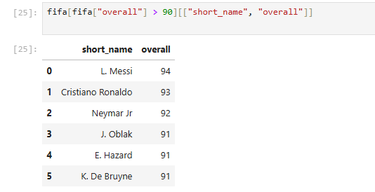

Q23. Get the nation position of players who play as RCB.

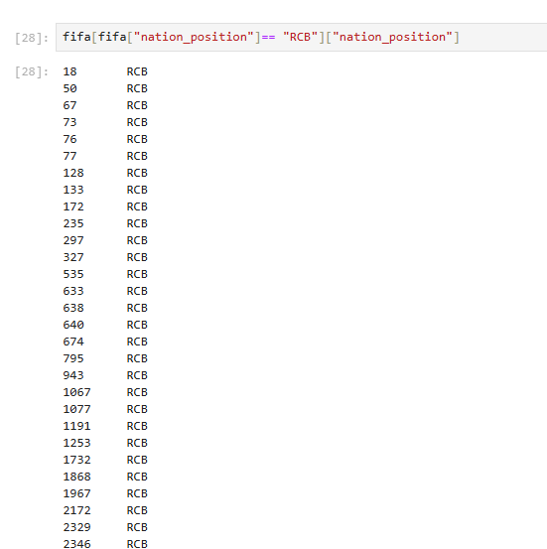

Q24. Get the count of players for each unique pace value

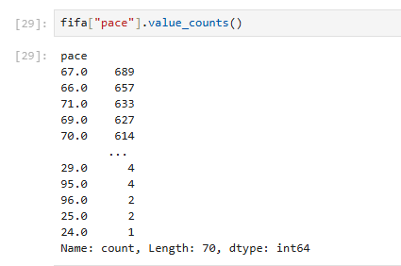

Q25. Get the names and release clauses of players with a release clause above 140 million

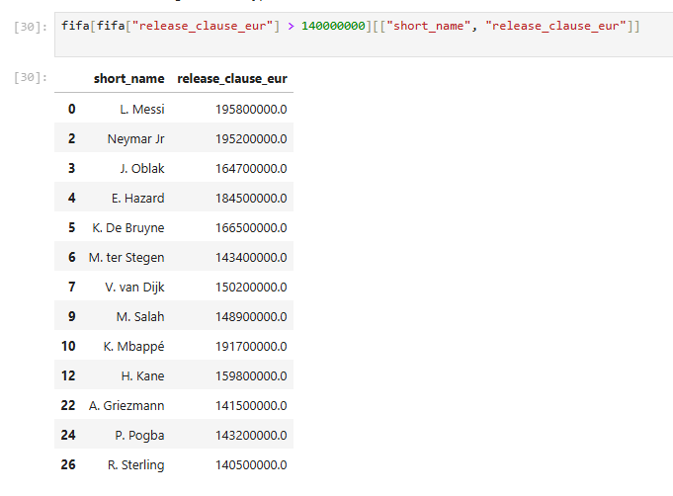

Q26. Get the team positions and shooting ratings of players with a shooting rating .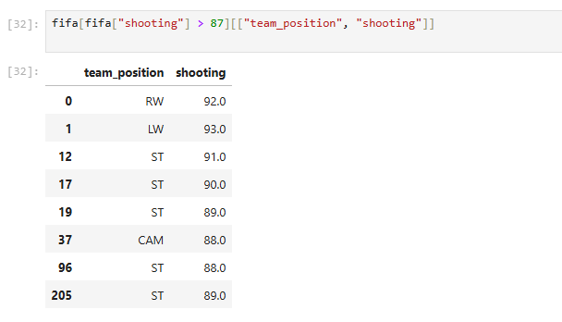

Q27. Get the top 10 highest-rated players in the FIFA dataset based on overall rating

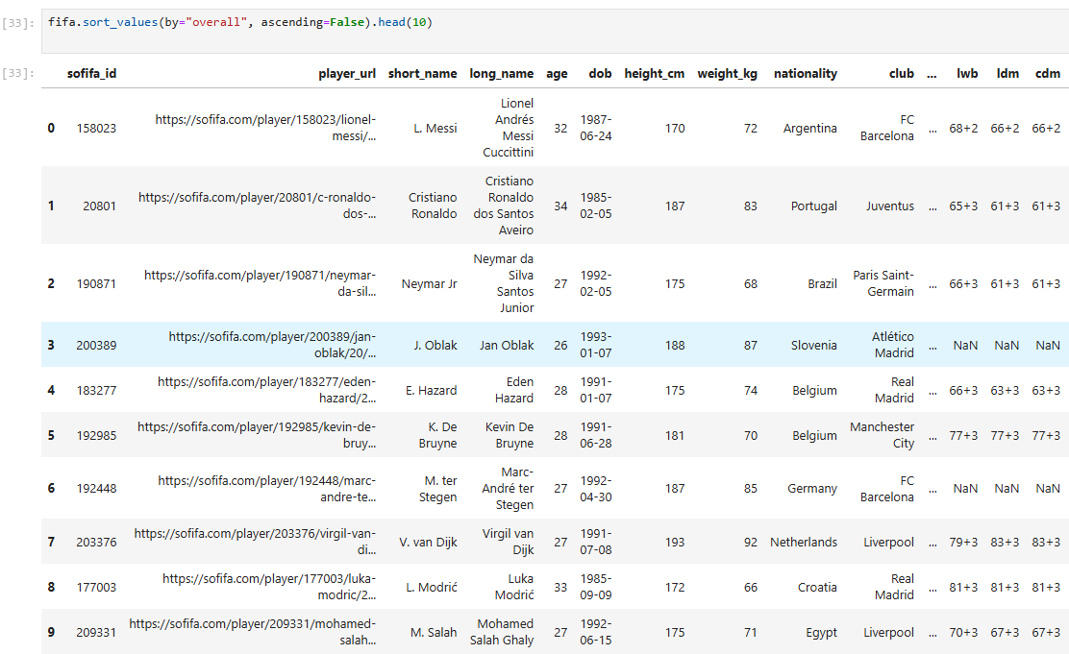

Q28. Get the five youngest players

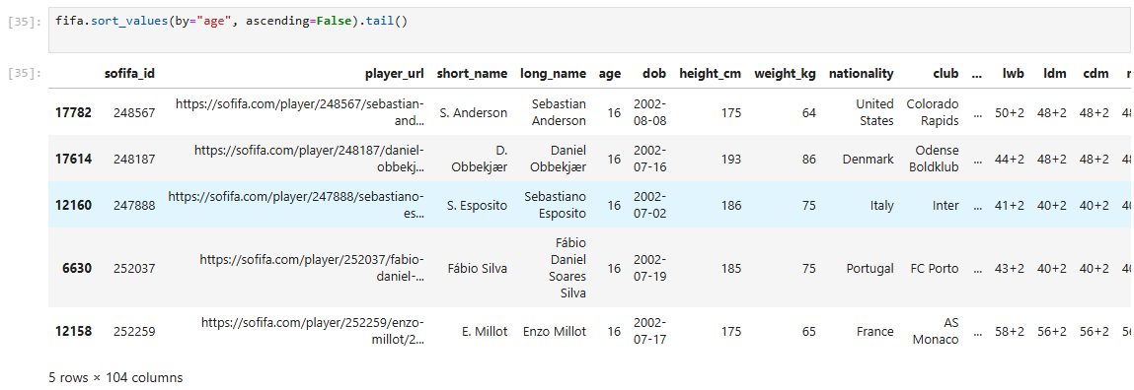

Q29. Get the top 3 players with the highest passing rating

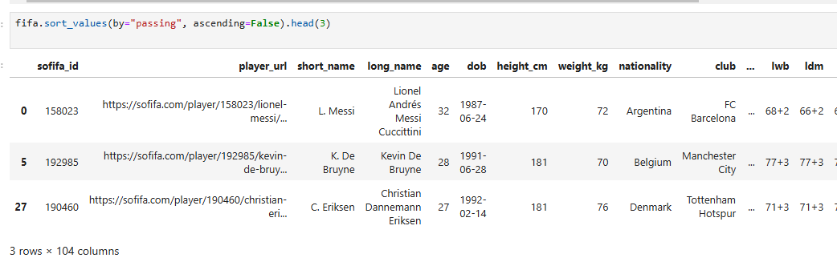

Q30. Get the number of players in each club from the FIFA dataset.

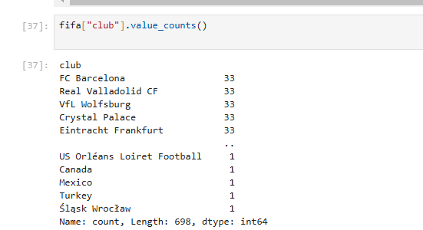

Q31. Get the average overall rating of players for each nationality

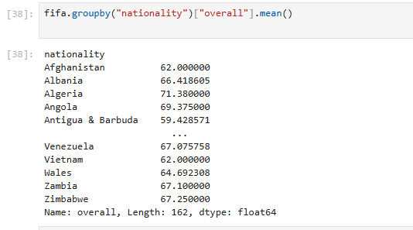

Q32. Retrieve the details of the player named J. White from the FIFA dataset.

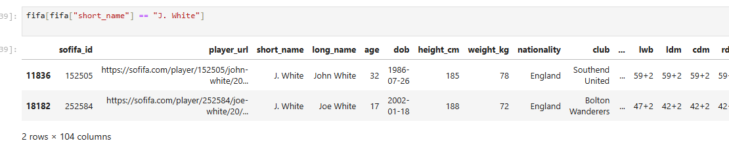

Q33. Get the names of players whose contracts were valid until 2019

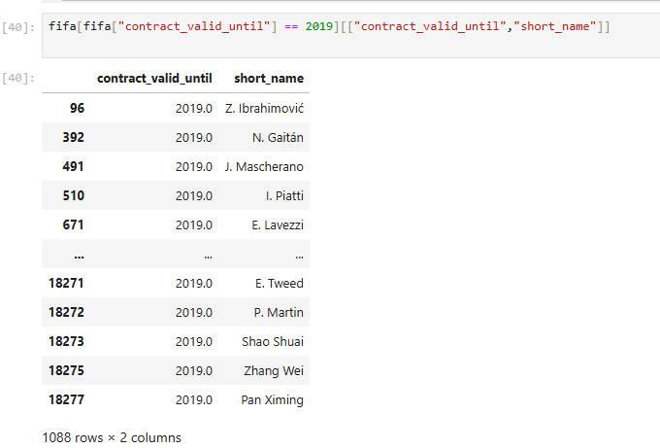

Q34. Classify players by rating and show the top 10

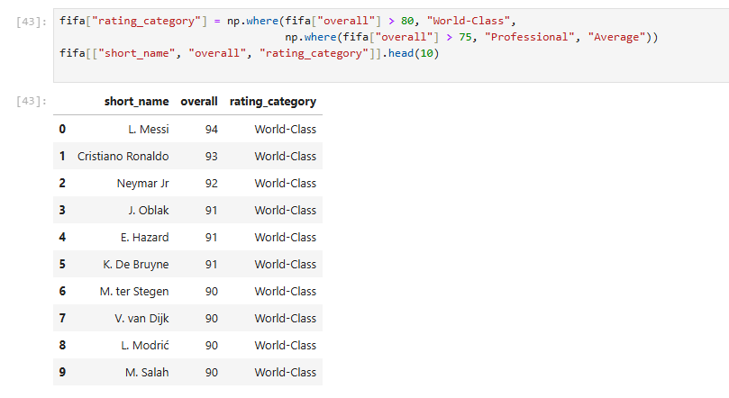

Q35. Get all players whose name contains 'Junior'

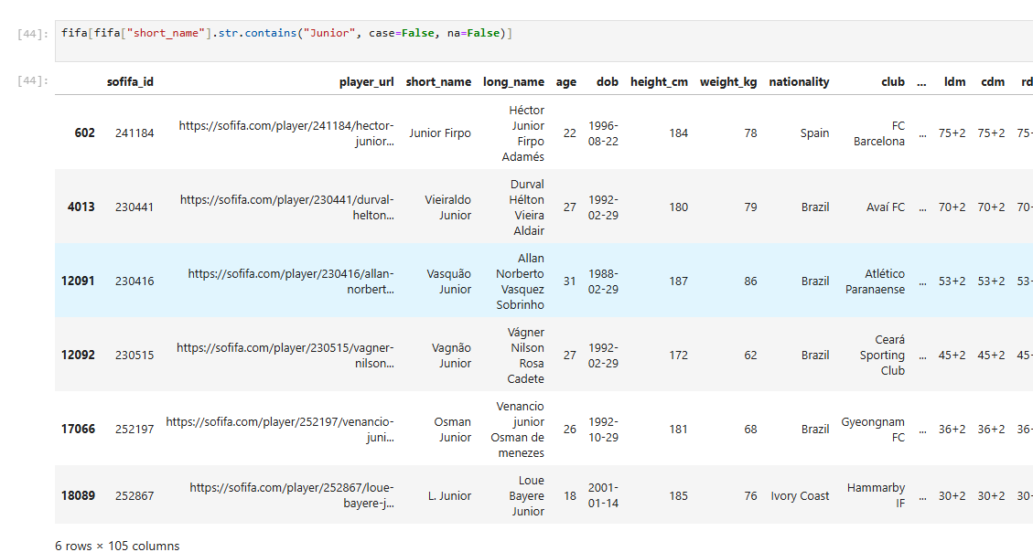

Q36. Split players' short names into first and last names and display

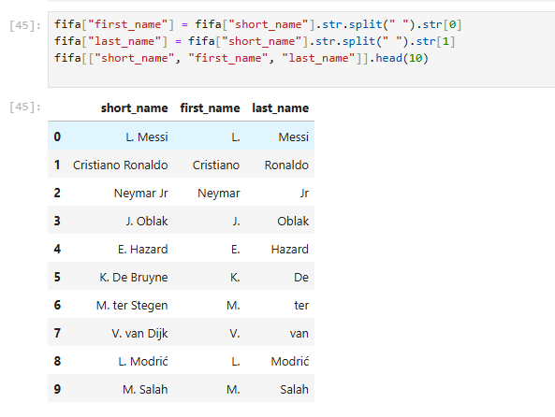

Q37. Get the names of players whose names start with 'R' 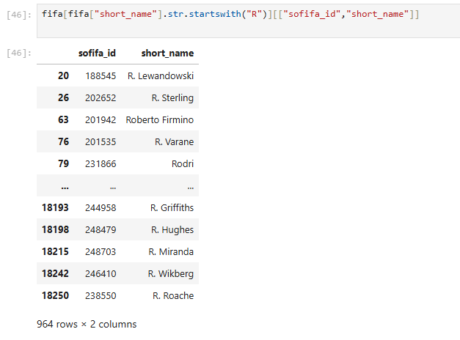

Q38. Get names of players whose names end with 't'

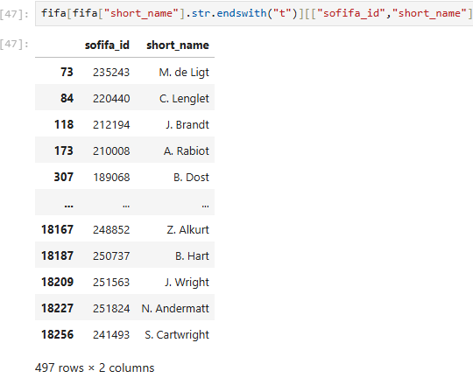

Q39. Get players with names over 20 characters.

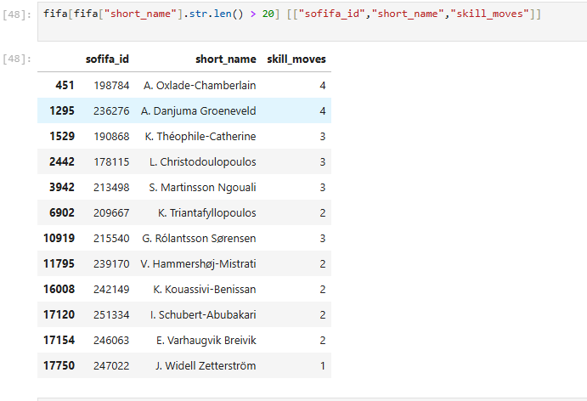

Q40. Sort players by date of birth in descending order.

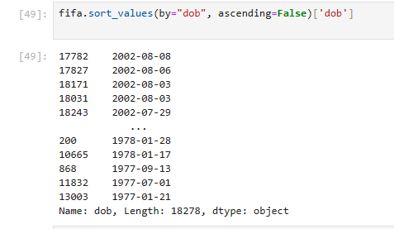

Q41. Get players with a 5-star weak foot

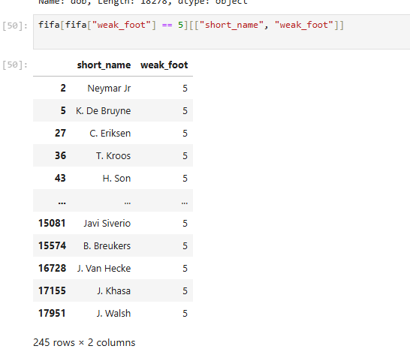

Q42. Get players with dribbling and passing both above 85.

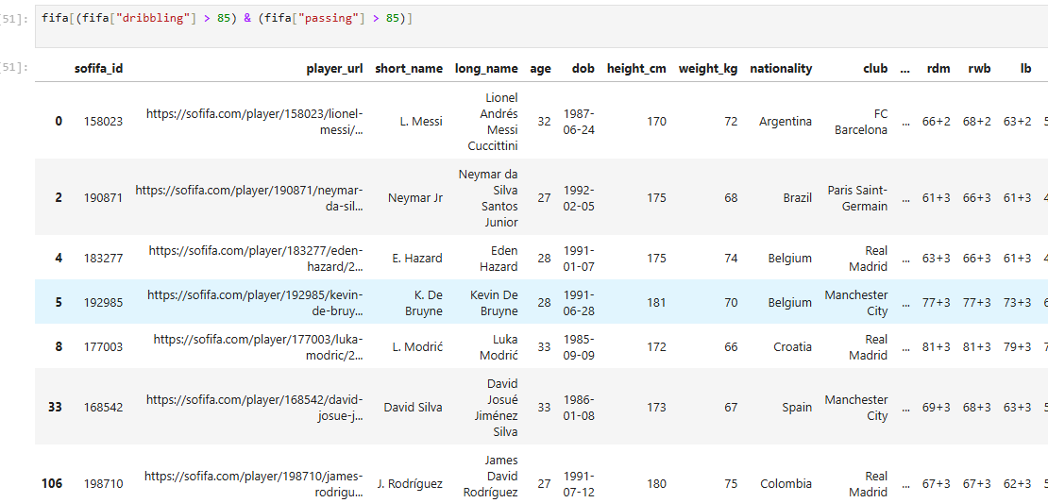

Q43. Combine first and last names, show top 10

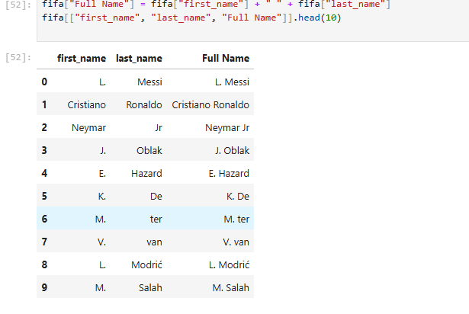

Q44. Plot the average wage by age

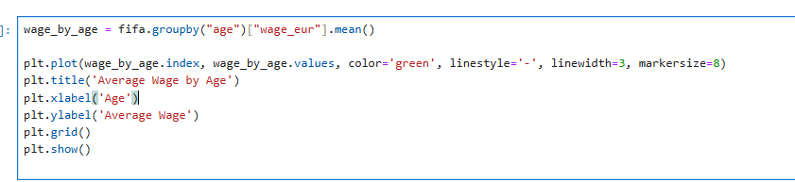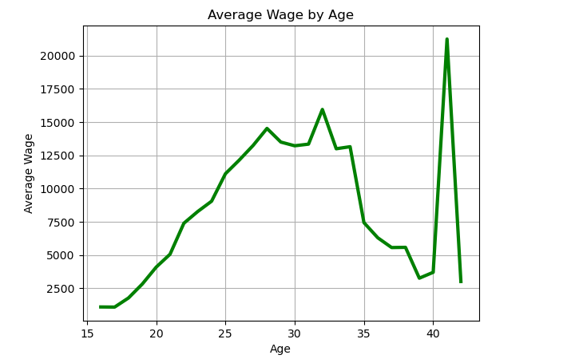

Q45. Plot average shooting ability by age.

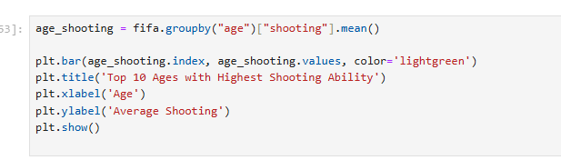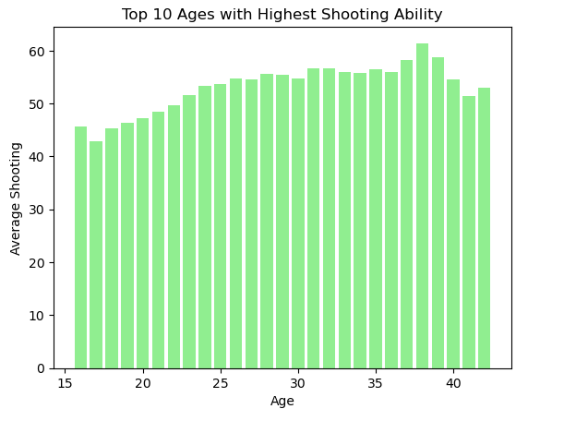

Q46. Plot a pie chart of the top 5 nationalities in the FIFA dataset.

